Octane Guidelines Document

Table of Contents

Purpose 3

**For all Teams:-** 3

Add Requirements 3

**For Test Analysts and USSD team** 7

Add Backlog Items 7

Adding tests to Application module 15

Add a Widget on DashBoard - optional 17

*Figure 1: Octane Home Page* 4

Figure 2: Requirements tree 5

Figure 3:RD ADD Item 6

Figure 4: Added Item - RD 7

Figure 5: Backlog Module 8

Figure 6: Backlog workflow 8

Figure 7: User story as Action 9

Figure 8: User Stories as - grouping 9

Figure 9: User Stories and tests 10

Figure 10: Link requirement from GT 11

Figure 11: Link RD to GT 12

Figure 12: Run Test 13

Figure 13: Running a manual test 14

Figure 14: Test Results 14

Figure 15: Test Status by Run 15

Figure 16: Application Modules 16

Figure 17: Add Application Module 17

Figure 18:Add Widget 18

Figure 19:Added Widgets on Dashboard 19

Figure 20: Add Gherkin test 20

Figure 21: Added Gherkin test 20

Figure 22: Run Script 22

Figure 23: Export Tests and steps 22

Figure 24: Extracted Xcel report 23

|  |  |  |
| --- | --- | --- |
| Revision | Date | Name |
| Draft | 10 March 2020 | Wilheminah Ngqola |
| Ver 0.1 | 27 March 2020 | Hilary Steyn |
| Ver 0.2 | 30 March 2020 | Wilheminah Ngqola |
| Ver 0.3 | 18 August 2020 | Wilheminah Ngqola |
| Final | 26 August 2020 | Wilheminah Ngqola |

# Purpose

The purpose of the document is to guide you on how to capture the Projects that you are working on, the Requirements, and tests etc. for later reporting.

*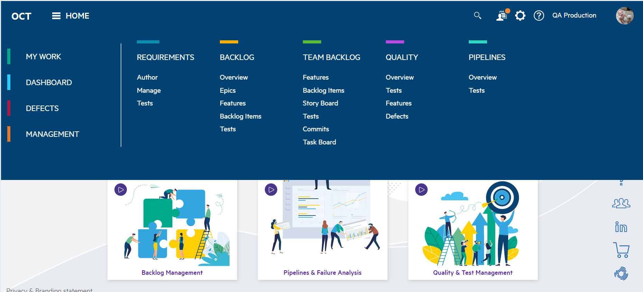Figure 1: Octane Home Page*

## **For all Teams:-**

## Add Requirements

From the HomePage, Click on the requirements to add requirements or any other document that you use as the source document:-

Click on the Requirements -> Overview and you should be able to see this tree on the left:-

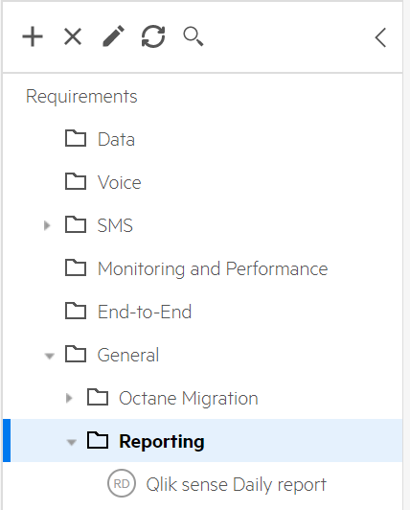

Figure 2: Requirements tree

All the Folders have been created, so you just have to work under the folder that best describes your project. For example - If you have a project that only uses SMS bundles, then it should be captured under the SMS Folder, Data bundles under data, and Integrated will be from projects which have all three. The General Folder will be mostly for team initiated projects, reporting and Administration stuff.

Now select the Folder and add the Project Name as the Project: Click on the + button to add an item. This Item will be a Requirement Document, give the description as well. And once done click on the Add button.

ADD:

* Name* – (Name of Project)
* Owner is populated by default
* Description – just a glimpse of what the project is all about
* Project Name* – (Can be the same as Name – for reporting purposes)
* Project status* – (The status of the project)
* Project Percentage – (The percentage of the Project status)
* Project Comments – (adhoc timeline of the project)

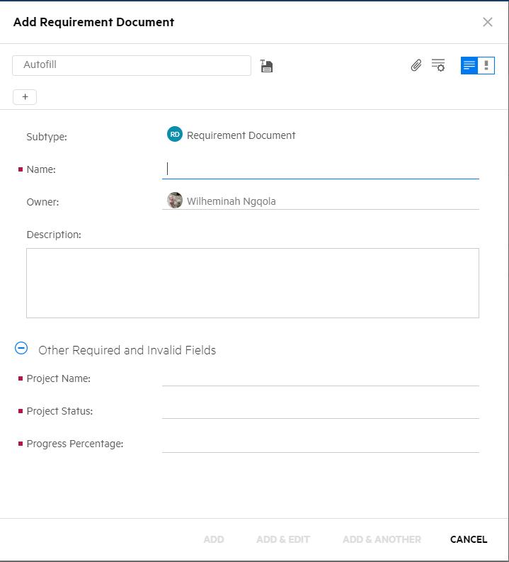

Figure 3:RD ADD Item

You can click on the clip icon to attach a requirements document, CR document or an email item as supporting document.

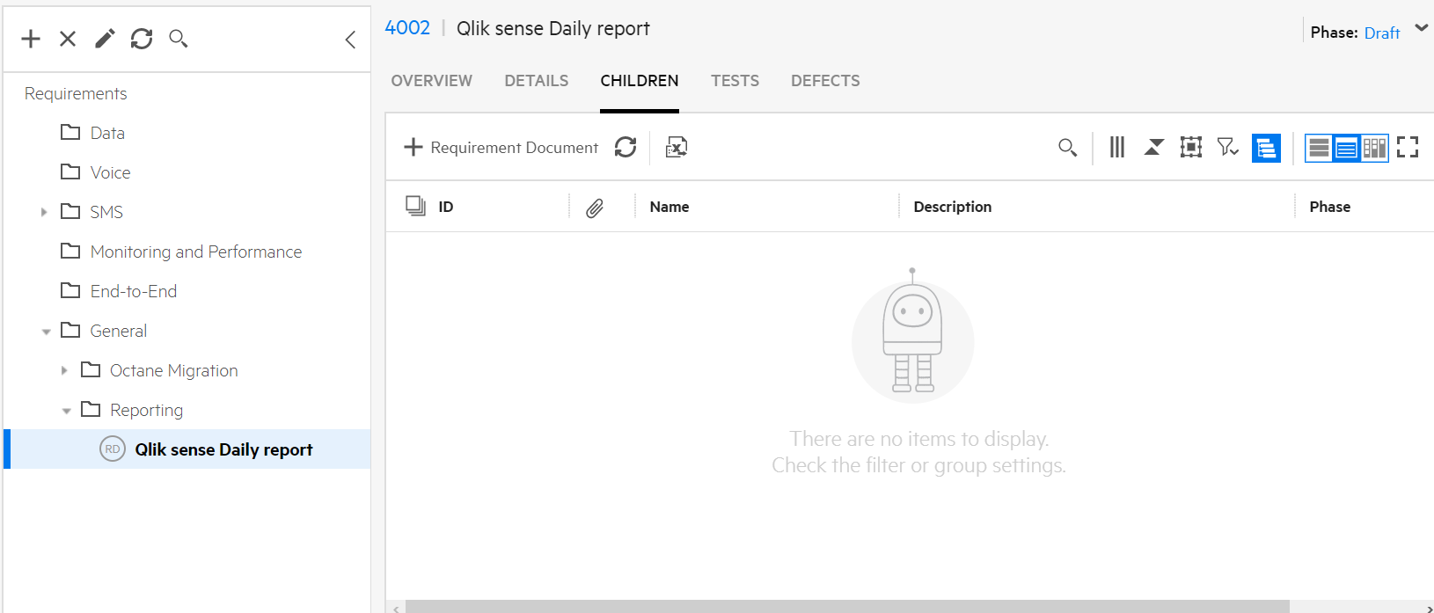

Figure 4: Added Item - RD

## **For Test Analysts and USSD team**

## Add Backlog Items

Go to the Homepage, and click on the Backlog module:-

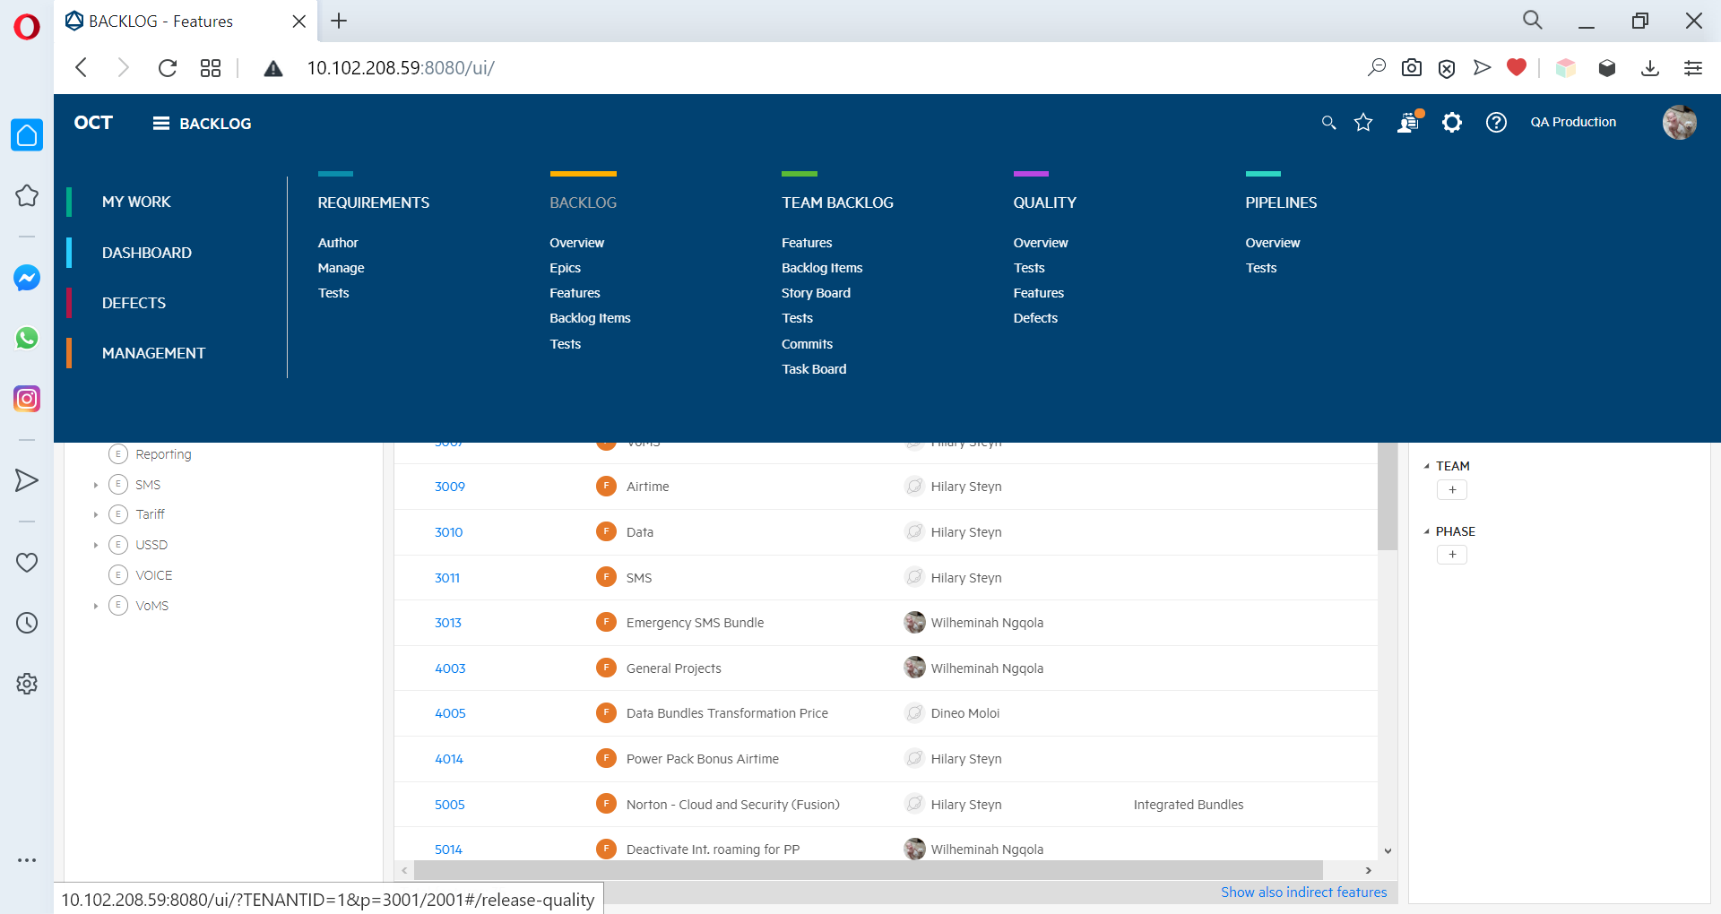

Figure 5: Backlog Module

On the Backlog module – Select the feature that you are working under…

The same structure that is n requirements is also under backlog. The backlog is arranged as follows

Figure 6: Backlog workflow

Epics: - Epics are already created – you do not need to add one.

Feature: - A feature is more like you project name

User Story: - User story is an action that you will be performing to create a test or a grouping of multiple similar tests - see example –

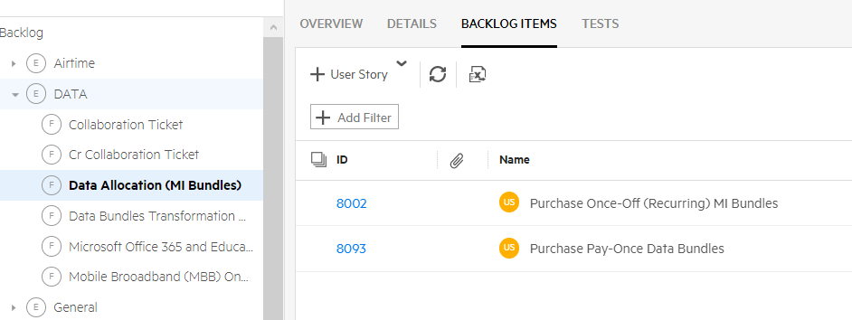

Figure 7: User story as Action

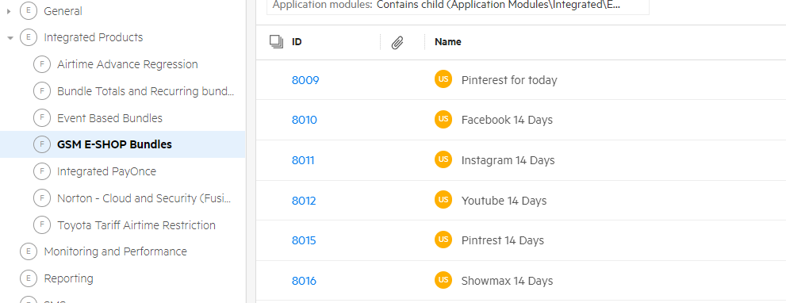

Figure 8: User Stories as - grouping

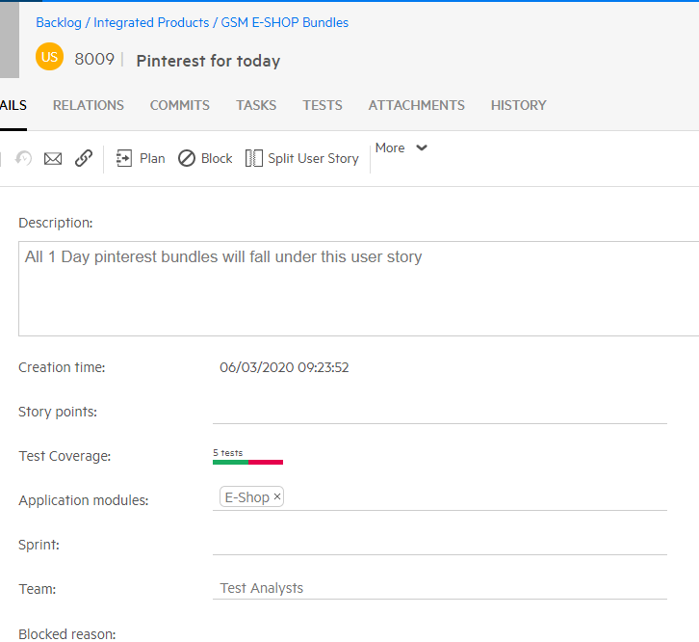

Figure 9: User Stories and tests

User story “Pinterest for today has **5** test which are only distinguished by size and cost. Do group them under one user story.

Manual/Gherkin Tests:-

You can create a manual test if it’s going to be run manually – usually for a very small project. However create a gherkin test for lots of tests that will also be run for regression.

N.B. After adding a manual/Gherkin test it is important that you link it to the Project (RD in requirements) – for the sake of reporting.

To do that:-

* select all the tests that requires to be linked
* Click on the relations tab

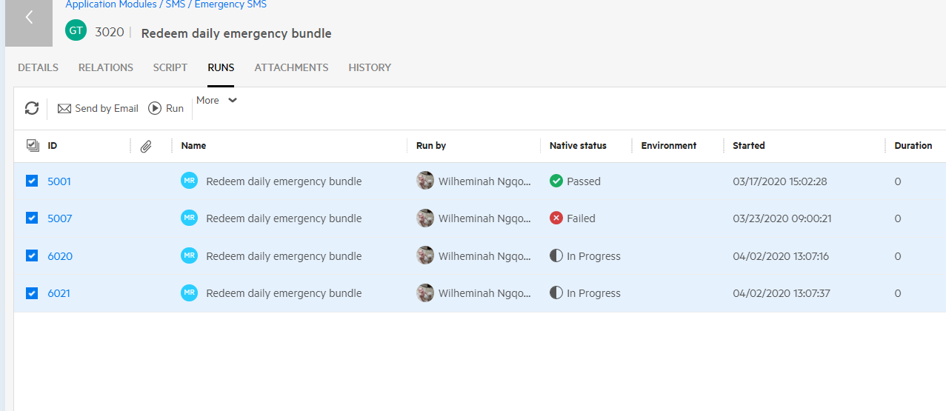

Figure 10: Link requirement from GT

### Click on the Add Relation, then select covering requirement document.

* A list of all RD’s will be displayed for you to select to select the right one

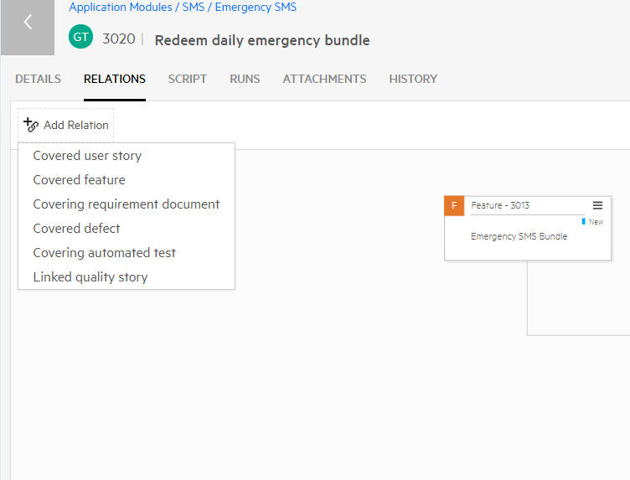

Figure 11: Link RD to GT

Once you are ready to run a manual test that you have captured,

* Go to the Quality Module
* Select the test that you want run
* Run the test

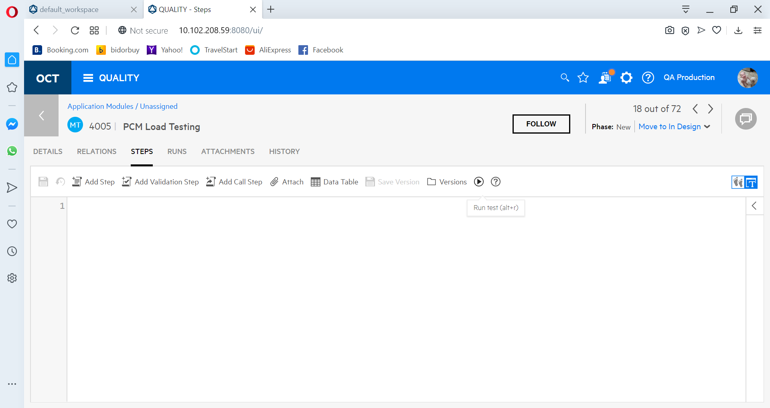

Figure 12: Run Test

* Manual Runner will Launch

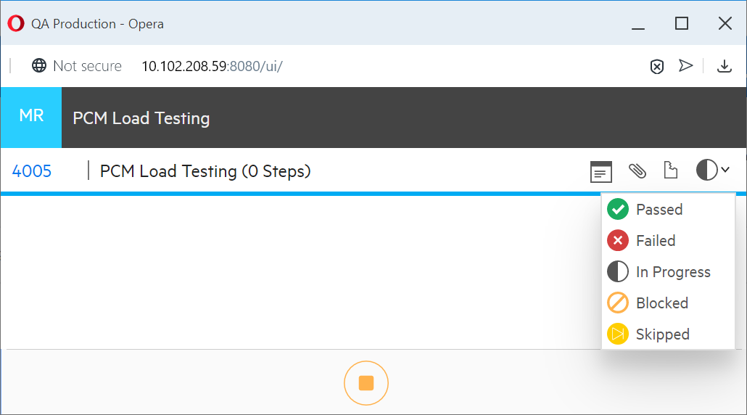

Figure 13: Running a manual test

* Indicate the verdict of the test by selecting the Status
* Click on the Stop button
* In the below case, I have selected Passed and the below is the result of the run:-

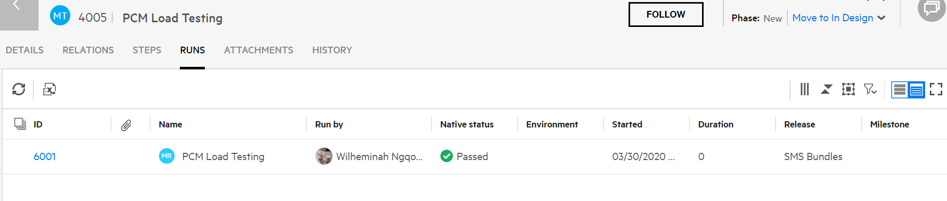

Figure 14: Test Results

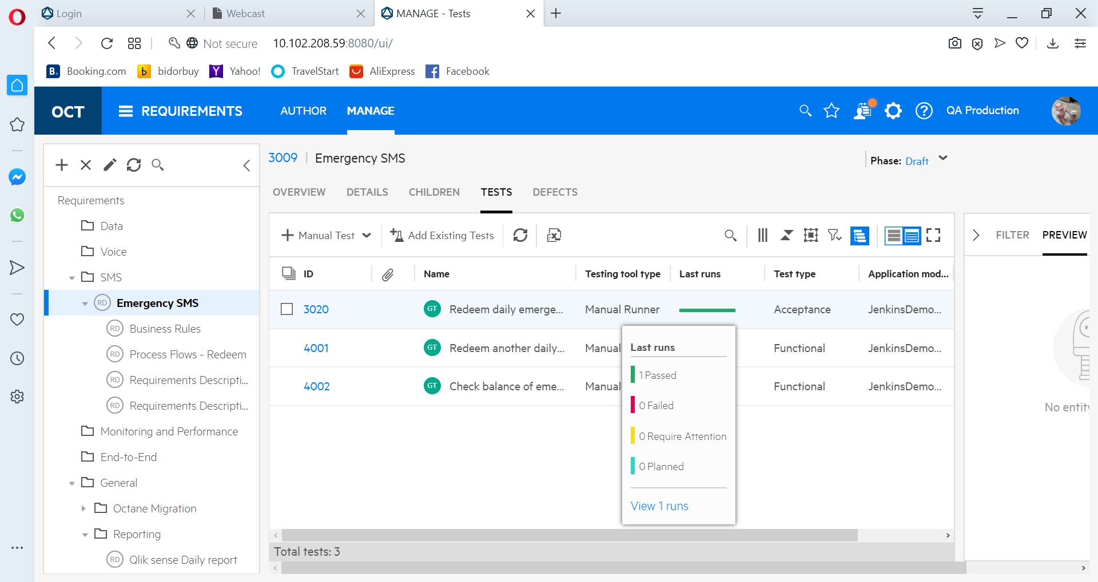

Figure 15: Test Status by Run

# Adding tests to Application module

It is important that you add tests to the Application module- From Quality to allow for Automation to take place when required. Same as with other Modules. Create a

The Application Module is arranged like other modules and therefore, you can Add you module under the existing ones – for example you will add a data related project under data :-

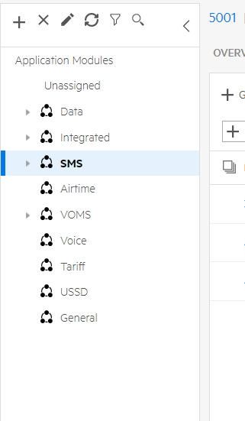

Figure 16: Application Modules

To add and application Module, Select the Main AM, the click on the + sign then select the shared application module:-

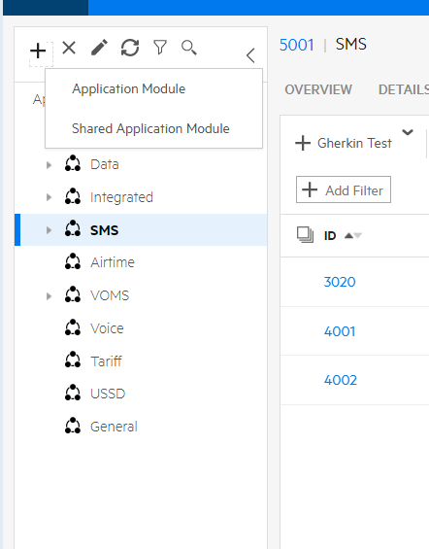

Figure 17: Add Application Module

Enter the name, preferably Project Name. Then link your tests to the Application module.

## Add a Widget on DashBoard - optional

A report will be made available once we have incorporated Qliksense, Otherwise, you can use the Dashboard and customise as follows:-

* Go to the Homepage, Dashboard
* Add a + sign to add a new Widget
* Go to Quality

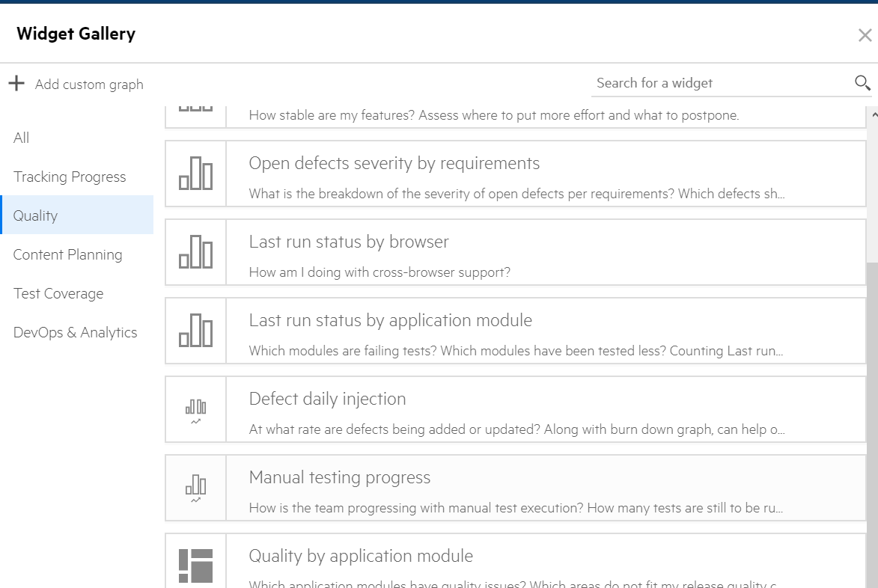

Figure 18:Add Widget

* The results will be the left graph.

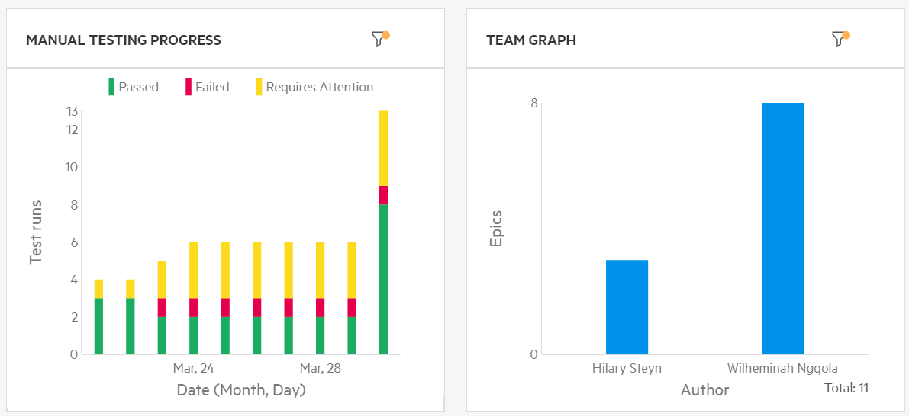

Figure 19:Added Widgets on Dashboard

After Capturing Backlog items/User stories/Test description

* Add a Gherkin Test
* Add the name
* Specify the test type
* Add the Backlog coverage
* Click on Add button

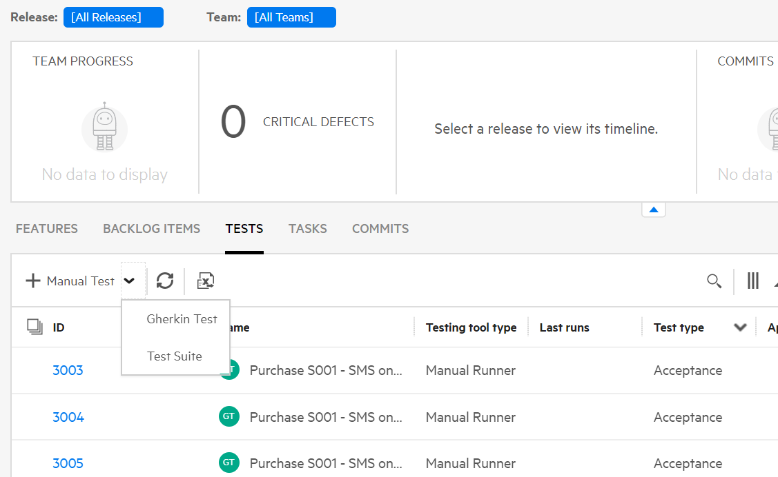

Figure 20: Add Gherkin test

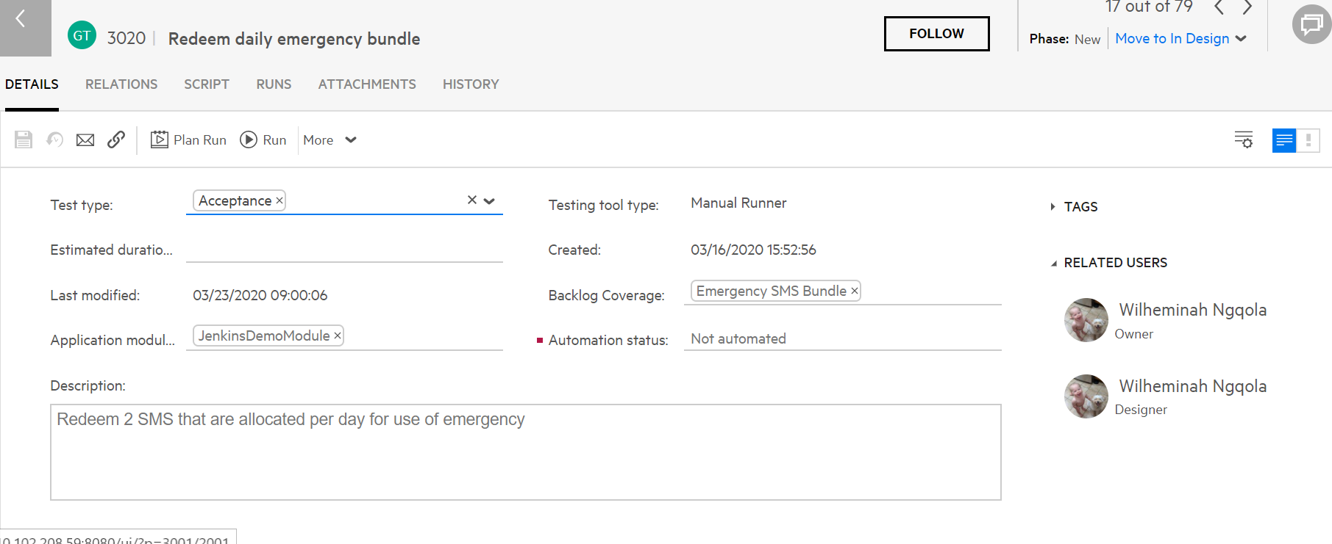

Figure 21: Added Gherkin test

Go to Scripts to **add** the test script and Save

Test Cases will be required to be Gherkin Tests as per requirement from the Automators.

The following is a sample of what the test will look like depending on what is required from your tests.

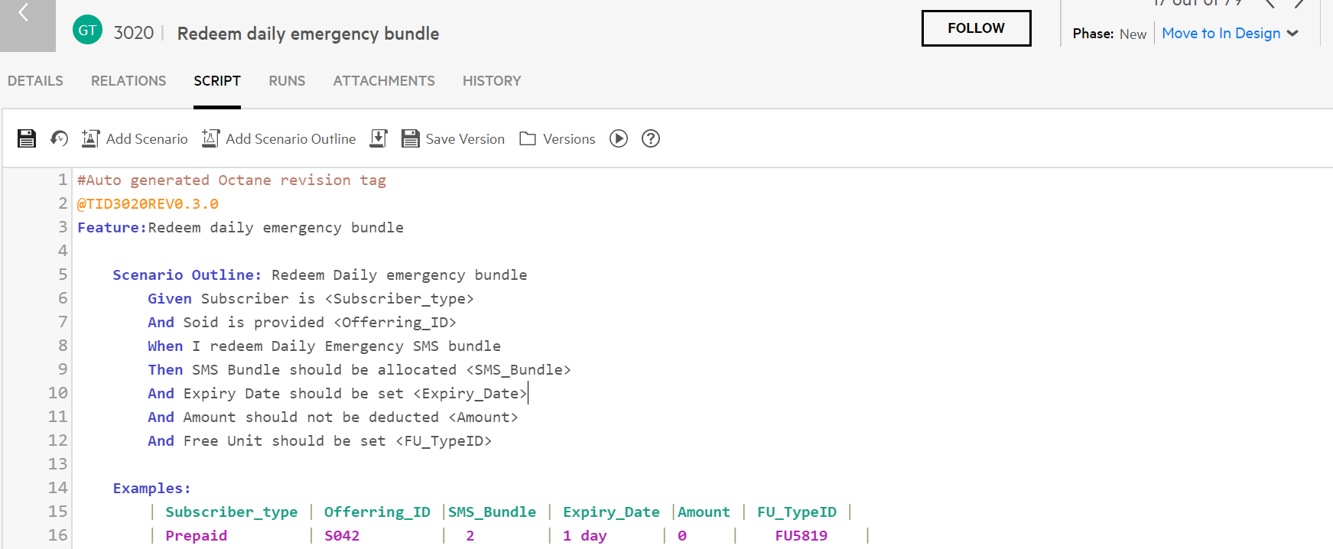

Figure 11: Added Test Script

Please note: Parameters dependent on Project Requirements. The example above is the information that you would usually find in the Price-Book.

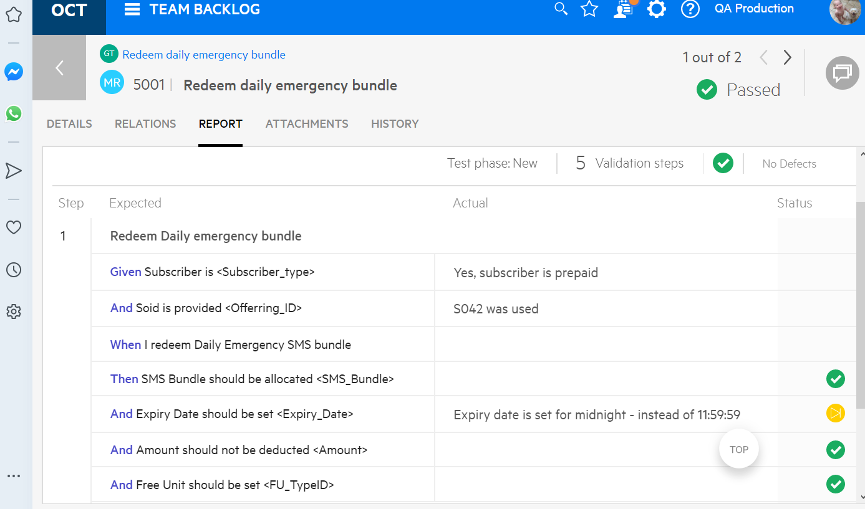

Figure 22: Run Script

Proceed to the dashboard or Qliksense to extract a report. For the meantime go to Quality -> Tests and select the tests that you want to extract -> clock on more, then select Export test steps to Excel.

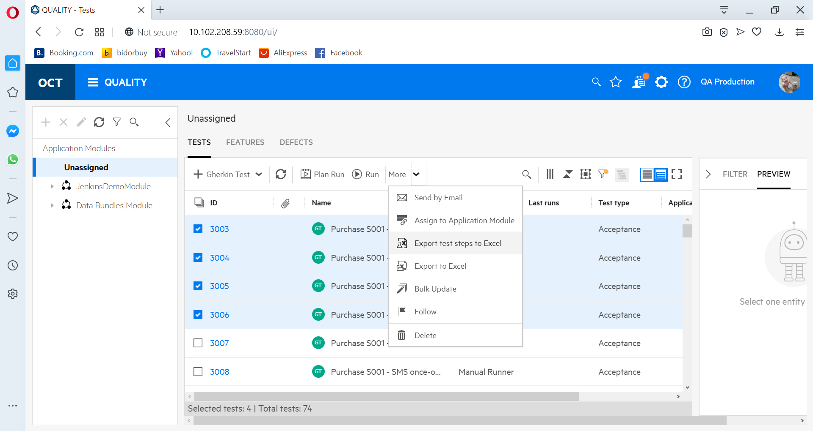

Figure 23: Export Tests and steps

An Excel report will be created with Tabs, Tests and test steps.

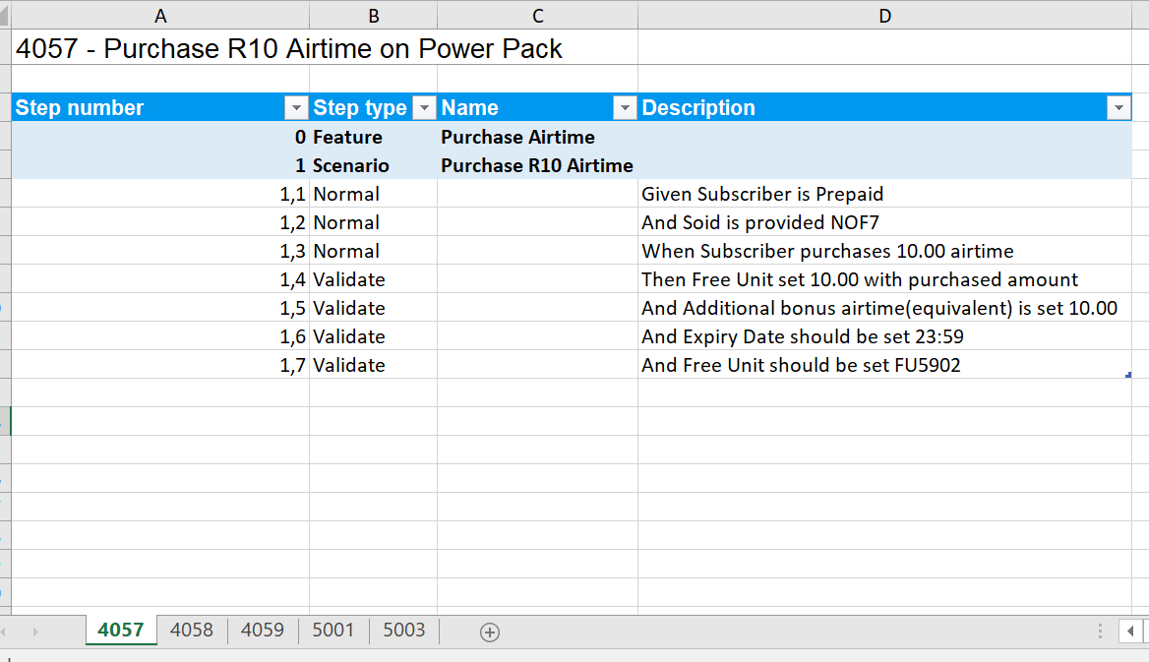

Figure 24: Extracted Xcel report